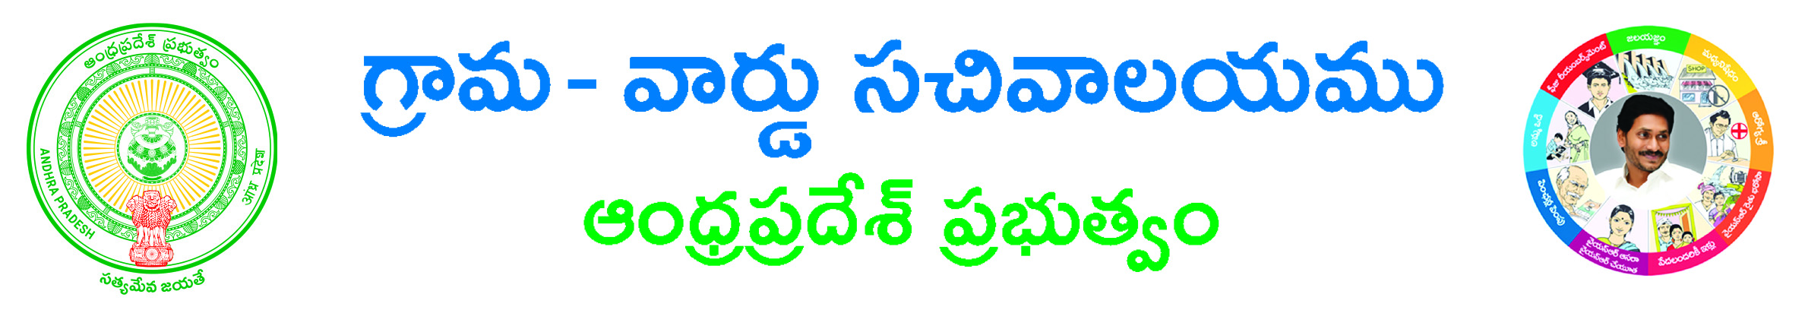
AFFIDAVIT

I, ___________________________________, S/o, W/o, Sri _______________________
_____________________________ aged about ____________ years having an occupation of ______________________ resident of ______ D. No __________________________ Locality\Landmark ________________________ Village / town ___________________ ______________ Mandal ______________ District ______________ Pincode do hereby solemnly affirm and state on oath as follows.

I am the deponent herein as such I am well acquainted with the facts of this affidavit. I submit that I am the resident of above address, I am doing _______________________
(Profession) and getting Rs.__________________ in Rupees ____________________
___________ only per annum from all sources mentioned below except the above said income. I belong to ____________ Caste, which comes under SC/ST/BC/Others. The income certificate is necessary for my Son / Daughter ___________________________
Who is studying_________________________________________ at _____________
He / she required income certificate for getting scholarship / Fee reimbursement, hence I am giving this affidavit along with income declaration.

INCOME DECLARATION
(As per G.O., RT No.1307, Rev., (Ser.II) Dept., and Dt.13.9.2010)

1 | Name of the student | :
2 | Date of Birth | :
3 | (i) Name of the Father | :
 | (ii) Whether Employed | :
 | (iii) If employed designation, if not other profession | :
 | (iv) Salary per month | :
4 | (i) Name of the Mother | :
 | (ii) Whether Employed | :
 | (iii) If employed, designation, if not other profession | :
 | (iv). Salary per month | :
5 | Agricultural holding of the parents mention extent
 | (i) In the name of Father | :
 | (ii) In the name of Mother | :
 | (a) Crops grown in land | :
 | (b) Whether Dry or wet land | :
 | I Annual income from agricultural land | :
6 | Business mention the trade / name of business Income derived from the venture | :
7 | (i) Number of vehicles owned by the family | :
 | (ii) Whether used for personal / private use only | :
 | (iii) Mention type of vehicles ( two wheeler / three wheeler / four wheeler) | : | Regd No.
 | (iv) Vehicle registered on whose name | :

8 | (i) Type of house mention Whether RCC / thatched / Tiled roofed | :
 | (ii) Mentioned, whether Indiramma House | :
 | (iii) Cost construction of House | :
 | (iv) Whether constructed with loan, if so amount and bank Branch | :
 | (v) Any other type of house | :
9 | (i)Whether living in own house or rented house | :
 | (ii) If rented, mention rent amount | :
10 | Telephone/Mobile Number | :
11 | Total family income from all sources | :
12 | Ration Card Number | :
13 | Aadhar Card Number | :
14 | Email | :

I shall be liable for penal action both civil and criminal, if the above facts are false in future besides recovery of the scholarship with penal interest under the revenue recovery act. Therefore, I request the concerned revenue authorities may be pleased to accept this affidavit and issue income certificate to my son/daughter _______________________ ____________________________________for scholarship / fee reimbursement purpose.

The above facts are true and correct to the best of my knowledge and belief.

Name & signature of the student Name & Signature of the Parent
DEPONENT
Date: / /20
Place:
Solemnly affirm and signed before me at on / / 20
Attested by:

Signature of the Notary

Procedure: (following to be enclosed)
1) Application Form*
2) Ration Card copy/EPIC CARD/AADAR CARD#
3) Copy of IT Returns/pay slip/Any other document#

*-mandatory #-any one of them

